INDEMNITY OF PAYMENT 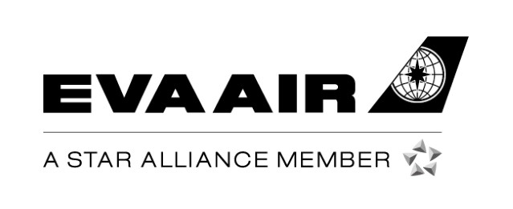

To ensure the financial security of credit card holders, EVA Air requires that credit cards used to make ticket purchases are available for verification before passengers are accepted for travel.
I, the undersigned and holder of the credit card used to make the ticket purchase, understand and accept that special conditions apply because I will not be one of the traveling party and that my credit card will not be available for verification at check-in. I affirm and authorize the ticket purchase for the passengers and itineraries listed below:

Passenger Information
Passenger’s English Name (as listed in booking reference) | 1ST Flight No. | Date  (mm/dd/yyyy) | Itinerary | Document Number
Credit Card Holder’s Information and Agreement
Name Passport (ID Number) / Travel Document Number
Contact No. (Country Code) (Area Code) Telephone No.
Residential Address
Email Address Cost of the ticket(s)
Type of Credit Card Credit Card No.

I agree to pay the full amount in cash or by alternative credit card when requested to do so by EVA Air in the event that the original credit card purchase is refused or canceled for any reason.
Type of Credit Card Credit Card No
Expiry Date Signature of Credit Card Holder
By signing this document, you agree to use your own credit card (held in your own name) and in consideration of EVA Air accepting your payment for the above purposes by persons other than yourself, to indemnify and hold harmless EVA Air from any loss arising from the rejection by the relevant payment account issuer (for any reason) of the transaction, and to forthwith upon demand by EVA Air pay the whole amount owing for the transaction in whatever form EVA Air requires.
Note
- Please sign the document in the presence of our staff. You will need to bring your original and alternate credit card and one item of photo ID.
- This information is confidential and will be stored by EVA Air. It will only be used in the event of a dispute regarding the booking transaction.

Signature of Credit Card Holder
Verified and approved on behalf of EVA Air (signature and stamp required)

Department Date

